**TRACK ME**

**1.HOME PAGE**

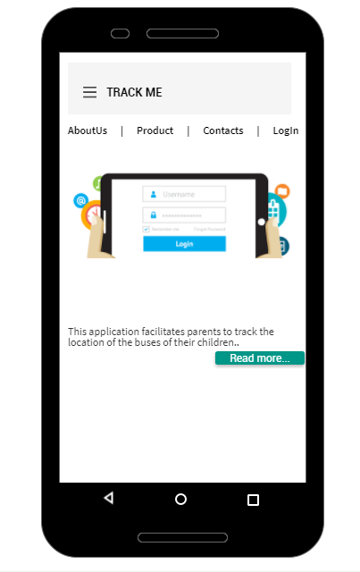

**2. ABOUT US**

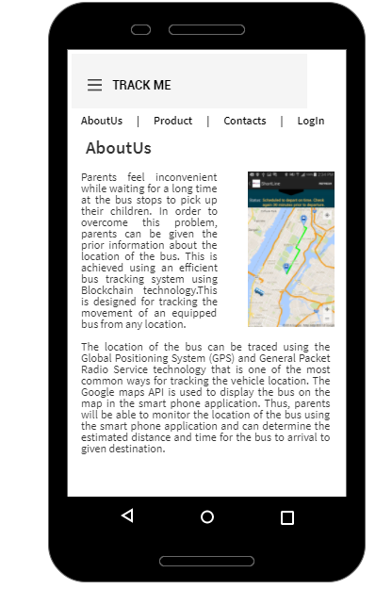

**3**. **PRODUCT**

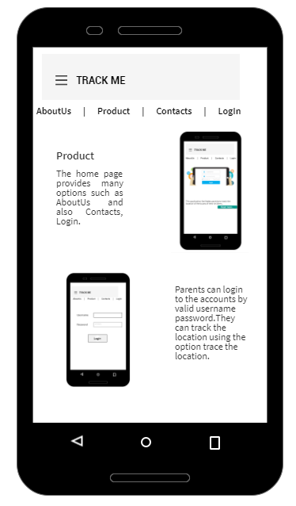

**4. CONTACTS**

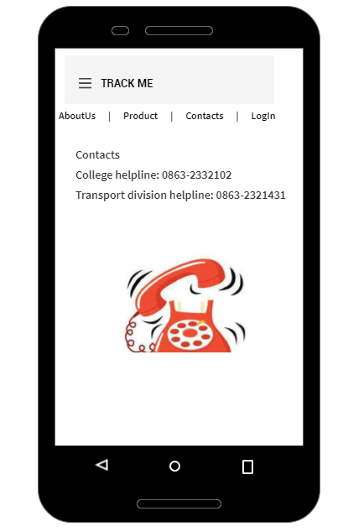

**5. LOGIN**

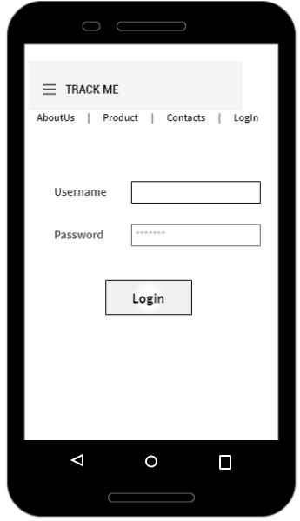

**6. SELECT BUS ROUTES**

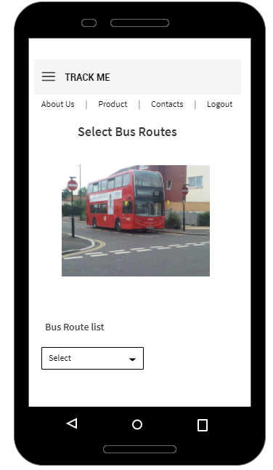

**7. BUS DETAILS**

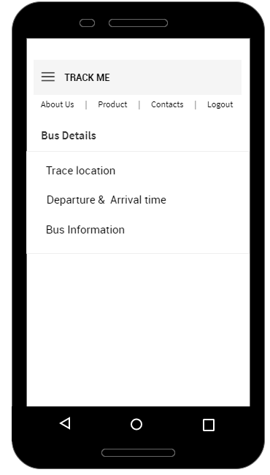

**8. TRACE LOCATION**

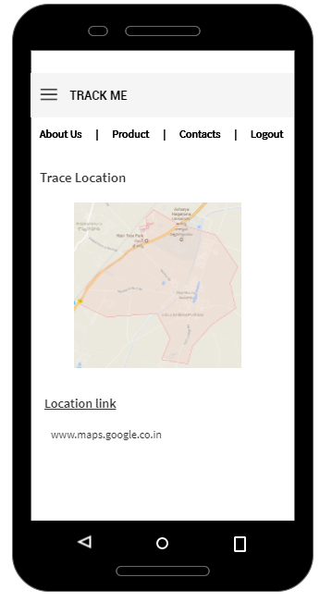

**9. DEPARTURE AND ARRIVAL TIME**

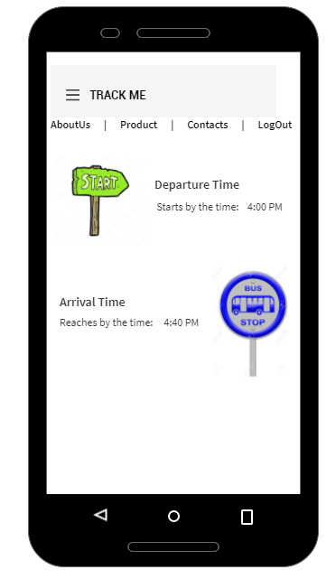

**10. BUS INFORMATION**

